Jason Palmeri

Web 200

Professor Soriano

8/23/2021

1. <https://www.madza.dev/>

I’ve seen this website show up in my google news feed a few times. I am personally a fan of darker themes and designs, its just better on the eyes. Right off the bat I can see the website is built using some sort of JavaScript framework, looking at the DevTools there are traces of React. I like how on first load you can just see the hero image and call to action, but as you scroll down a little he has his featured projects pop up as well as his articles. The website looks modern and runs really smooth.

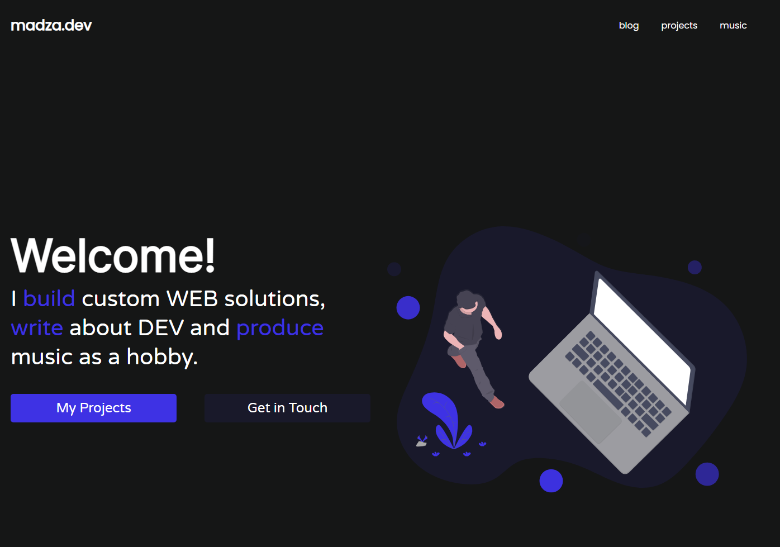

1. <https://itch.io>

This is a website I go to pretty often when I’m bored, this website is a great place to find free indie games and other things like game assets. While the website content is great I’m not a big fan of no dark mode, personally I feel like every major website should provide a dark theme. The front page is great as it shows trending games and featured. I’m not a big fan of the double column navigation menu on the left, and I feel like it could maybe be a pop out instead of a static piece.

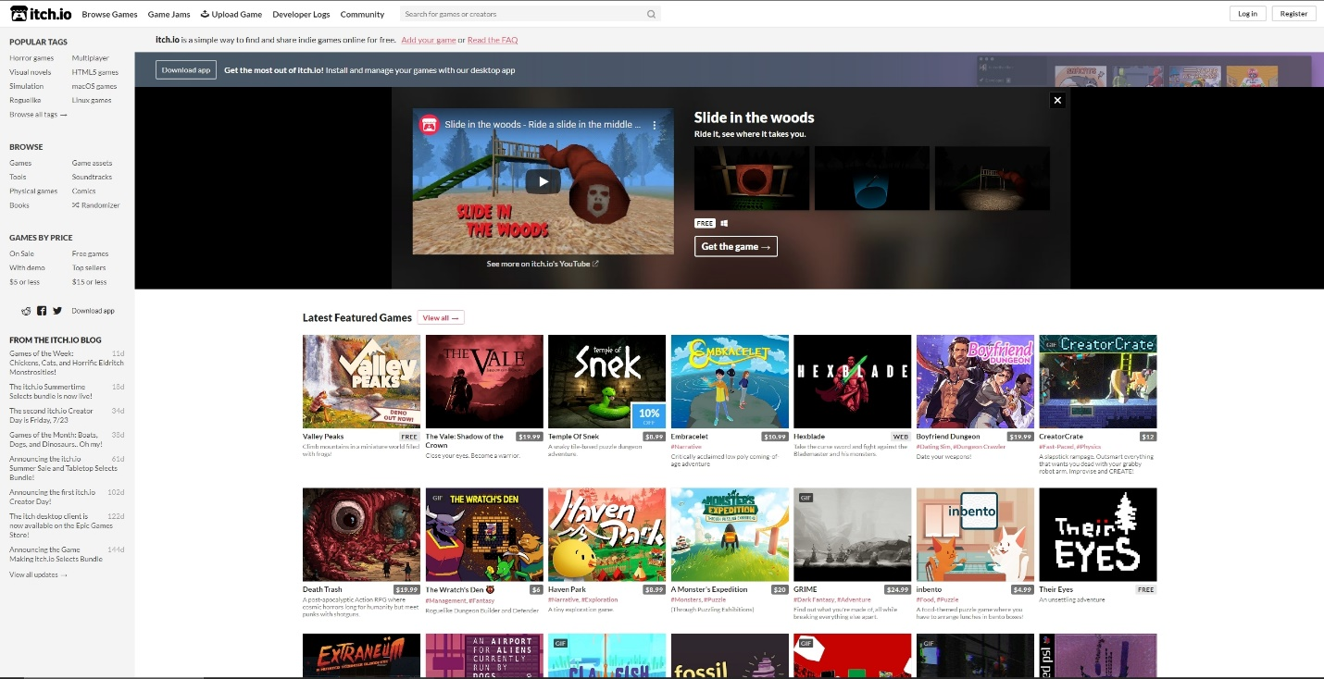

1. <https://twitch.tv>

I have multiple monitors, so I usually keep a tab of twitch open on the side whenever I’m doing anything. A few years back twitch changed the layout of the entire site, and at first it was really weird, but thinking back on it now, it was a great change. Twitch went from this:

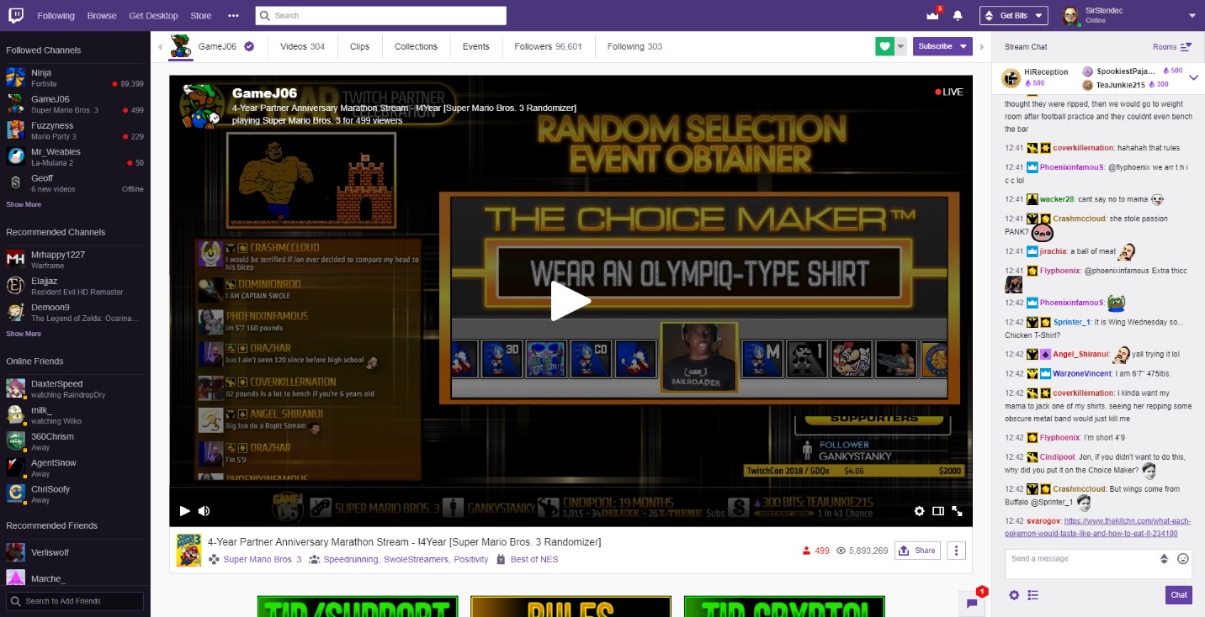

To this:

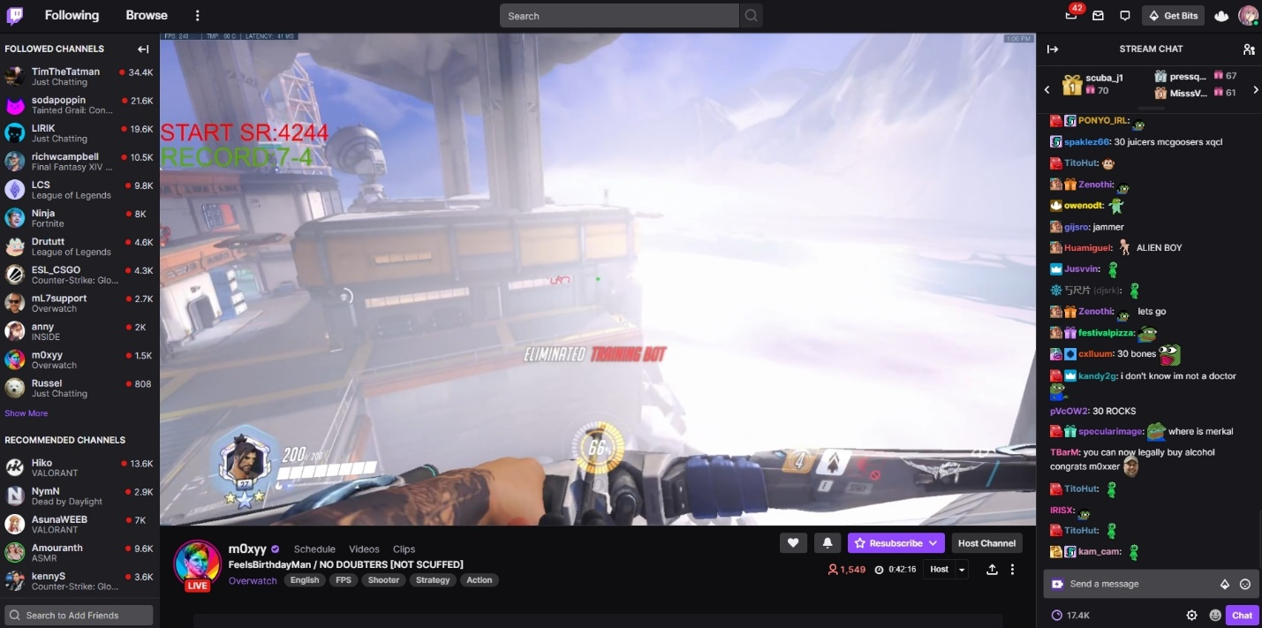

They changed from their old-style purple theme to a more dark mode type theme and made things more modern like their buttons and other UI elements. They moved around the streamers name and made it into a card like element at the bottom instead of taking up space in the top.